**Assignment 2**

1. **First-Visit Monte-Carlo**

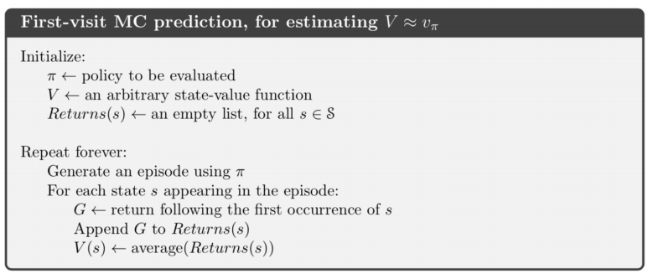

An episode is generated from a random starting state. And then for each state occurred in the episode, only the first occurrence is used to update G value.

In my implementation, total time of iteration is 35000. In every episode, I set an upper limit of 100 steps to avoid episodes that’s too long.

The value and policy of each state are shown below. And it can be proved that each state would take the shortest path to destination.

|  |  |  |  |  |  |
| --- | --- | --- | --- | --- | --- |
| **-8.7→** | **0.0** | **-15.4←** | **-25.1←** | **-30.3←** | **-31.7←** |
| **-17.3↑** | **-16.3↑** | **-22.6↑** | **-28.4←** | **-31.5←** | **-31.9↓** |
| **-25.4↑** | **-26.2↑** | **-28.4↑** | **-30.5↑** | **-30.9↓** | **-30.1↓** |
| **-31.1↑** | **-31.6↑** | **-31.6↑** | **-30.6→** | **-28.2↓** | **-24.9↓** |
| **-34.1↑** | **-34.3↑** | **-32.3→** | **-28.5→** | **-22.5→** | **-15.5↓** |
| **-34.4↑** | **-34.3→** | **-31.4→** | **-25.7→** | **-15.7→** | **0.0** |

1. **First-Visit Monte-Carlo**

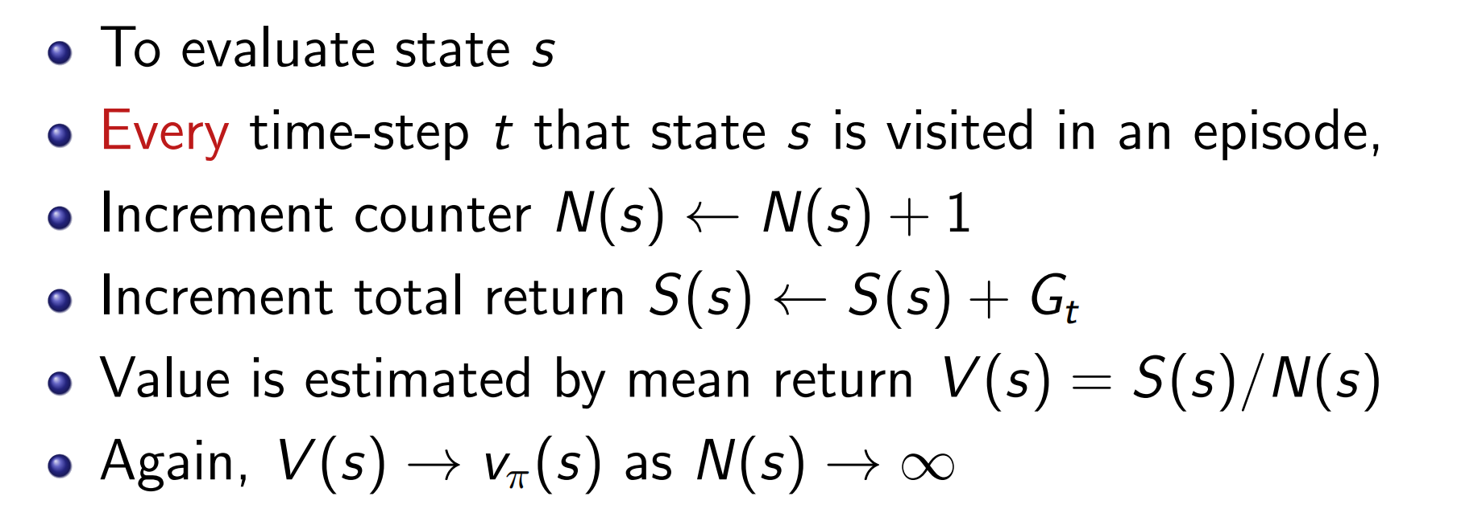

The case is quite similar for first-time monte-carlo. The difference is that in one episode, each state could be updated multiple times according to the order.

The value and policy of each state are shown below. And it can be proved that each state would take the shortest path to destination.

|  |  |  |  |  |  |
| --- | --- | --- | --- | --- | --- |
| **-8.7→** | **0.0** | **-14.5←** | **-23.0←** | **-27.5←** | **-29.2←** |
| **-16.8↑** | **-15.9↑** | **-21.1↑** | **-25.8←** | **-28.4←** | **-29.0↓** |
| **-24.1↑** | **-24.6↑** | **-26.3↑** | **-27.7↑** | **-28.1↓** | **-27.5↓** |
| **-29.1↑** | **-29.2↑** | **-29.0↑** | **-27.9→** | **-25.8↓** | **-23.2↓** |
| **-31.8↑** | **-31.5↑** | **-29.8→** | **-26.1→** | **-20.9→** | **-14.5↓** |
| **-32.5↑** | **-31.8→** | **-29.0→** | **-23.5→** | **-14.8→** | **0.0** |

1. **Temporal-Difference TD(0)**

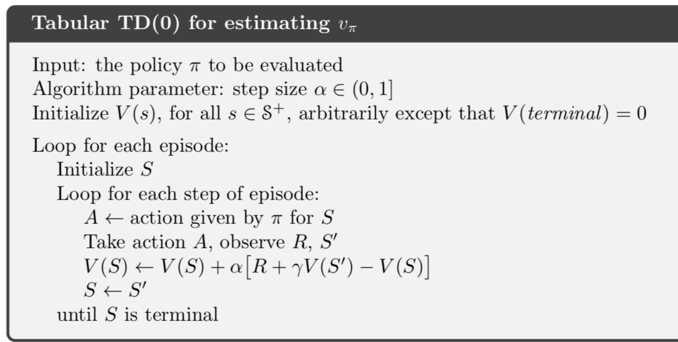

Different from MC, Temporal Different (TD) use the Bellman equation to estimate the value, and then updates the estimate as the target value. The advantage is that it can update after every step which can be seen as online learning.

The implementation is similar, first generate random episodes and update states using TD(0) mentioned above. $α$ is set to 0.5, and $γ$ is set to 1.

The value and policy of each state are shown below. And it can be proved that each state would take the shortest path to destination.

|  |  |  |  |  |  |
| --- | --- | --- | --- | --- | --- |
| **-3.5→** | **0.0** | **-10.1←** | **-15.5←** | **-28.9←** | **-38.8←** |
| **-11.8↑** | **-20.9↑** | **-30.8↑** | **-36.3←** | **-34.6↑** | **-37.0↓** |
| **-18.9↑** | **-26.4↑** | **-32.2←** | **-34.3←** | **-31.2↓** | **-30.6↓** |
| **-35.0↑** | **-34.4↑** | **-36.4↑** | **-32.9→** | **-25.4↓** | **-16.4↓** |
| **-39.9↑** | **-37.4↑** | **-34.7→** | **-34.2→** | **-15.1→** | **-6.3↓** |
| **-42.1↑** | **-38.6→** | **-35.7→** | **-26.7→** | **-19.4→** | **0.0** |